PIZZA SALES SQL QUERIES

## **A. KPI’s**

**1. Total Revenue**:

SELECT SUM(total_price) AS Total_Revenue FROM pizza_sales;

*OUTPUT:*

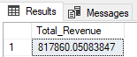

**2.Average Order Value**:

SELECT SUM(total_price) / COUNT(DISTINCT order_id) AS AVG_Order_Value FROM pizza_sales;

*OUTPUT:*

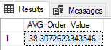

**3.Total Pizza Sold**:

SELECT SUM(quantity) AS Total_Pizza_Sold FROM pizza_sales;

*OUTPUT:*

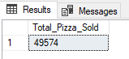

**4.Total Orders:**

SELECT COUNT(DISTINCT order_id) AS Total_orders FROM pizza_sales;

*OUTPUT:*

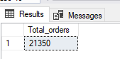

**5.Average Pizza Per Order:**

SELECT CAST(CAST(SUM(quantity) AS DECIMAL(10,2))/

CAST(COUNT(DISTINCT order_id)AS DECIMAL(10,2))AS DECIMAL(10,2))AS Avg_Pizza_per_order

FROM pizza_sales;

*OUTPUT:*

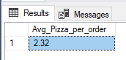

**B. Daily Trend for Total Orders:**

SELECT DATENAME(DW,order_date) AS order_day , COUNT(DISTINCT order_id) AS Total_orders

FROM pizza_sales

GROUP BY DATENAME(DW,order_date);

*OUTPUT:*

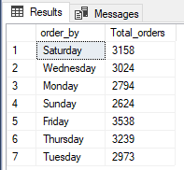

**C. Monthly Trend for Orders:**

SELECT DATENAME(MONTH,order_date) AS Month_name , COUNT(DISTINCT order_id) AS Total_orders

FROM pizza_sales

GROUP BY DATENAME(MONTH,order_date)

ORDER BY Total_orders DESC;

*OUTPUT:*

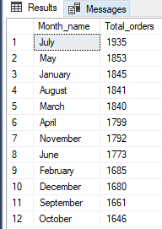

**D. % of Sales by Pizza Category:**

SELECT pizza_category, SUM(total_price)*100 /

(SELECT SUM(total_price) FROM pizza_sales) AS PTC

FROM pizza_sales

GROUP BY pizza_category;

*OUTPUT:*

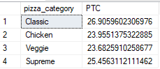

**E.** **% of Sales by Pizza Size:**

SELECT pizza_size, CAST(SUM (total_price) AS DECIMAL(10,2))AS total_sales,

CAST(SUM(total_price)*100 /

(SELECT SUM(total_price) FROM pizza_sales) AS DECIMAL (10,2)) AS PTC

FROM pizza_sales

GROUP BY Pizza_size

ORDER BY PTC DESC;

*OUTPUT:*

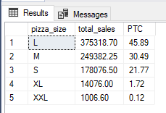

**F. Top 5 Pizzas by Revenue**:

SELECT TOP 5 pizza_name, SUM(total_price) AS total_revenue

FROM pizza_sales

GROUP BY pizza_name

ORDER BY total_revenue DESC;

*OUTPUT:*

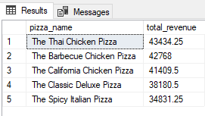

**G.** Bottom 5 Pizzas by Revenue:

SELECT TOP 5 pizza_name, SUM(total_price) AS total_revenue

FROM pizza_sales

GROUP BY pizza_name

ORDER BY total_revenue ASC;

*OUTPUT:*

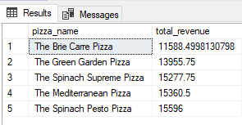

**H.** Top 5 Pizzas by quantity:

SELECT TOP 5 pizza_name, SUM(quantity) AS total_quantity

FROM pizza_sales

GROUP BY pizza_name

ORDER BY total_quantity DESC;

*OUTPUT:*

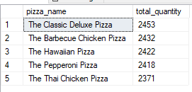

**I.** Bottom 5 Pizzas by quantity:

SELECT TOP 5 pizza_name, SUM(quantity) AS total_quantity

FROM pizza_sales

GROUP BY pizza_name

ORDER BY total_quantity ASC;

*OUTPUT:*

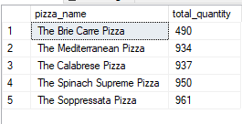

**J.** TOP 5 Pizzas by Orders:

SELECT TOP 5 pizza_name, COUNT(DISTINCT order_id) AS total_orders

FROM pizza_sales

GROUP BY pizza_name

ORDER BY total_orders DESC;

*OUTPUT:*

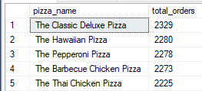

**K.** Bottom 5 Pizzas by Orders:

SELECT TOP 5 pizza_name, COUNT(DISTINCT order_id) AS total_orders

FROM pizza_sales

GROUP BY pizza_name

ORDER BY total_orders ASC;

*OUTPUT:*

